**VILNIUS UNIVERSITY**

**KAUNAS FACULTY**

INSTITUTE OF SOCIAL SCIENCES AND APPLIED INFORMATICS

Study programme Information Systems and Cyber Security

**MINDMAP, AHP, WEEKDONE AND OKR REPORT**

OLEKSII PARSHYN

JAKUMAR MATHUKIYA

**Team №4**

**Participants:**

Sofiia Chekmenova,

Oleksii Parshyn,

Yehor Poliarskyi,

Stepan Kozlov,

Jaykumar Mathukiya

Kaunas 2023

Table of contents

Mindmap 4

Analytic hierarchy process 10

Weekdone tool 11

OKR 12

Conclusion 14

**OKR №1** Create an OKR plan of the project (Oleksii Parshyn)

* 1. Take an opinion from every member of the team (This work was done in a group and unfortunately was not recorded, but on the basis of that work the calculations of AHP part of the project were done)
  2. Organize it and make all calculations (Basically AHP)

**Aim:**

* The aim is to provide information about our Mindmap, AHP, Weekdone tool and OKR plan.

**Tasks:**

* Analyze all the ideas in a mind map and come to a conclusion about the topic of the project we have chosen.
* Provide our AHP and a description of it.
* Provide a screenshot from Weekdone in which we distributed tasks.
* Provide OKR with a plan and an explanation for it.

# Mindmap

On the first stage of the project, we had to choose the best idea among all suggested. To make easier this proccess, we used the “Mindmap” tool, where indicated all ideas. Each team member provide his own idea. At first, we chose 6 parameters, acording to which we described our ideas. Here are all parameters:

1. Purpose and Functionality:

The development of a system for travelers to share their reviews of restaurants and attractions is highly relevant in today's digital age. With the increasing reliance on online resources for travel information, this system would serve as a valuable platform for individuals seeking authentic and up-to-date recommendations from fellow travelers. It addresses the need for real-time, user-generated content in the travel and hospitality sector.

2. User Interface (UI):

The complexity of the UI largely depends on the scope and features you wish to include. A user-friendly interface is crucial for encouraging user participation and engagement. While it may require some effort to design an intuitive and visually appealing UI, it's feasible to develop, especially with modern UI design tools and frameworks available today.

3. Accessibility and Availability:

Ensuring the system's accessibility across various devices and platforms is essential for its success. While there may be some challenges associated with optimizing the user experience for different devices, it's a common practice in software development. Responsive design and cross-platform development frameworks can help streamline this process.

4. Data Security and Privacy:

Given the nature of the system, data security and privacy are paramount concerns. Traveler reviews may contain personal information and preferences. Implementing robust data protection measures is imperative to build trust among users. This topic aligns with our studies in information systems, as it involves handling sensitive user data and complying with data protection regulations.

5. Price and challenges of Development:

The development of such a system would involve several stages, including design, development, testing, and maintenance. The cost and challenges would depend on factors such as the scale of the project, the size of the development team, and the choice of technologies. While there will be associated costs, they can be managed through careful planning and resource allocation.

6. Storage and Data Management:

The amount of data to be stored will increase as the system gains users and reviews. Implementing efficient data management and storage solutions is crucial to ensure system performance and scalability. Cloud-based storage and databases can be employed to address potential data volume concerns.

Here you can see the screenshots from the Mindmap: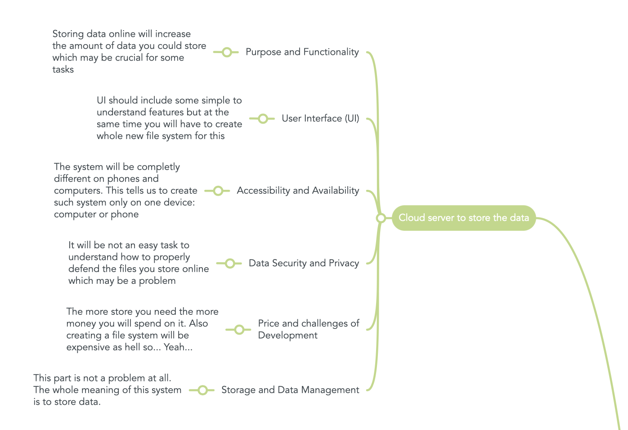

**Figure 1. Idea №1. Cloud server to store the data**

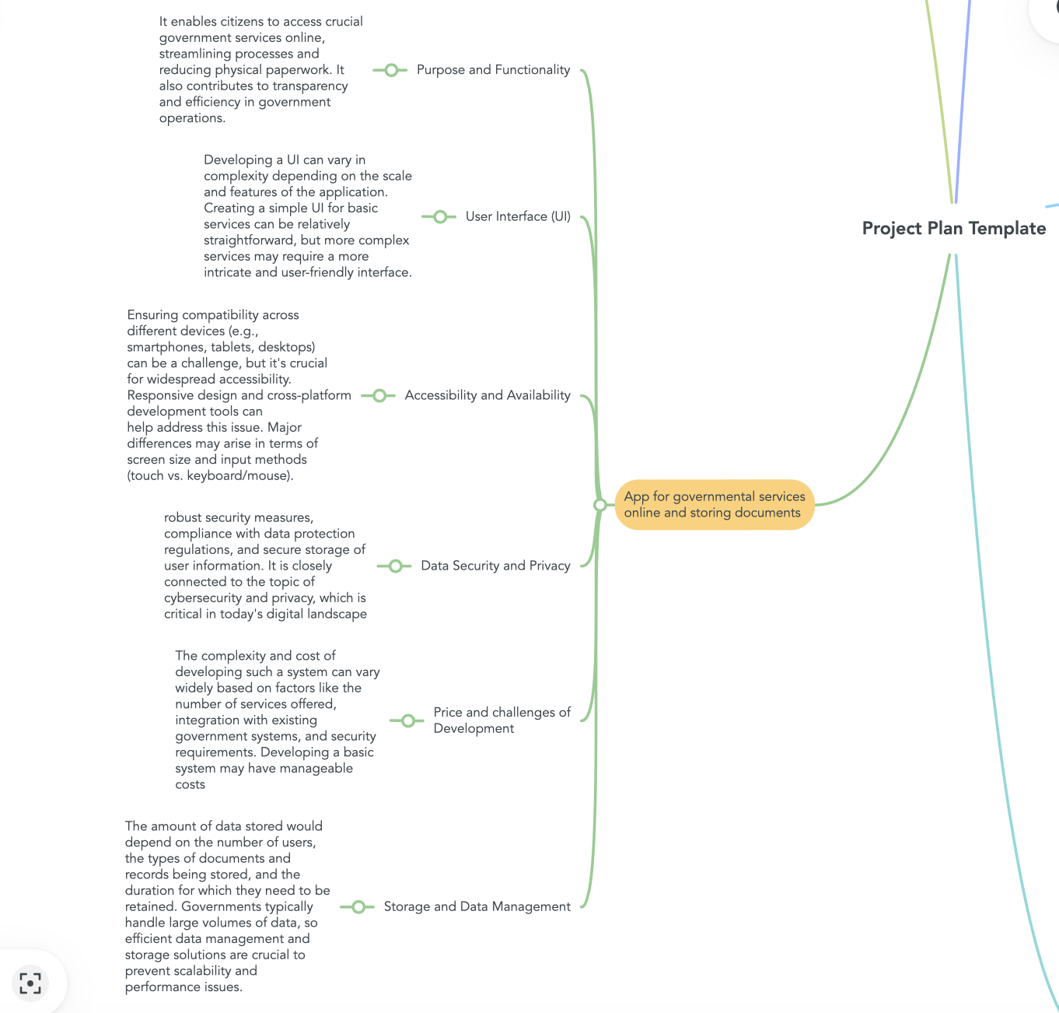

**Figure 2. Idea №2. App for governmental services online and storing documents**

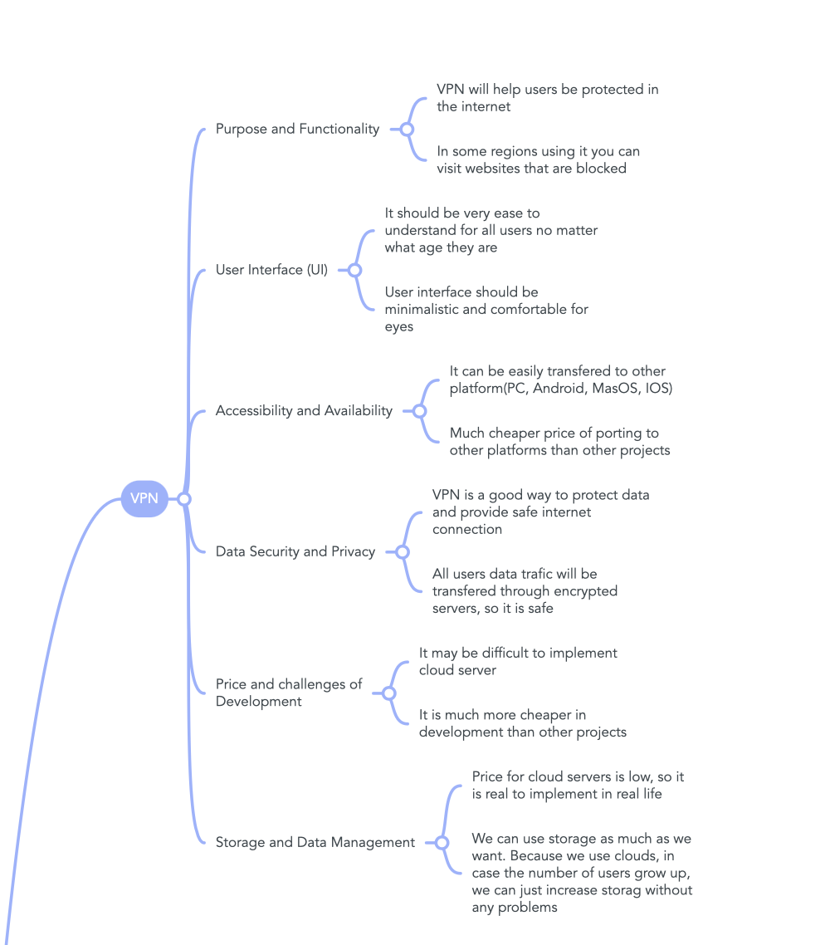

**Figure 3. Idea №3. VPN**

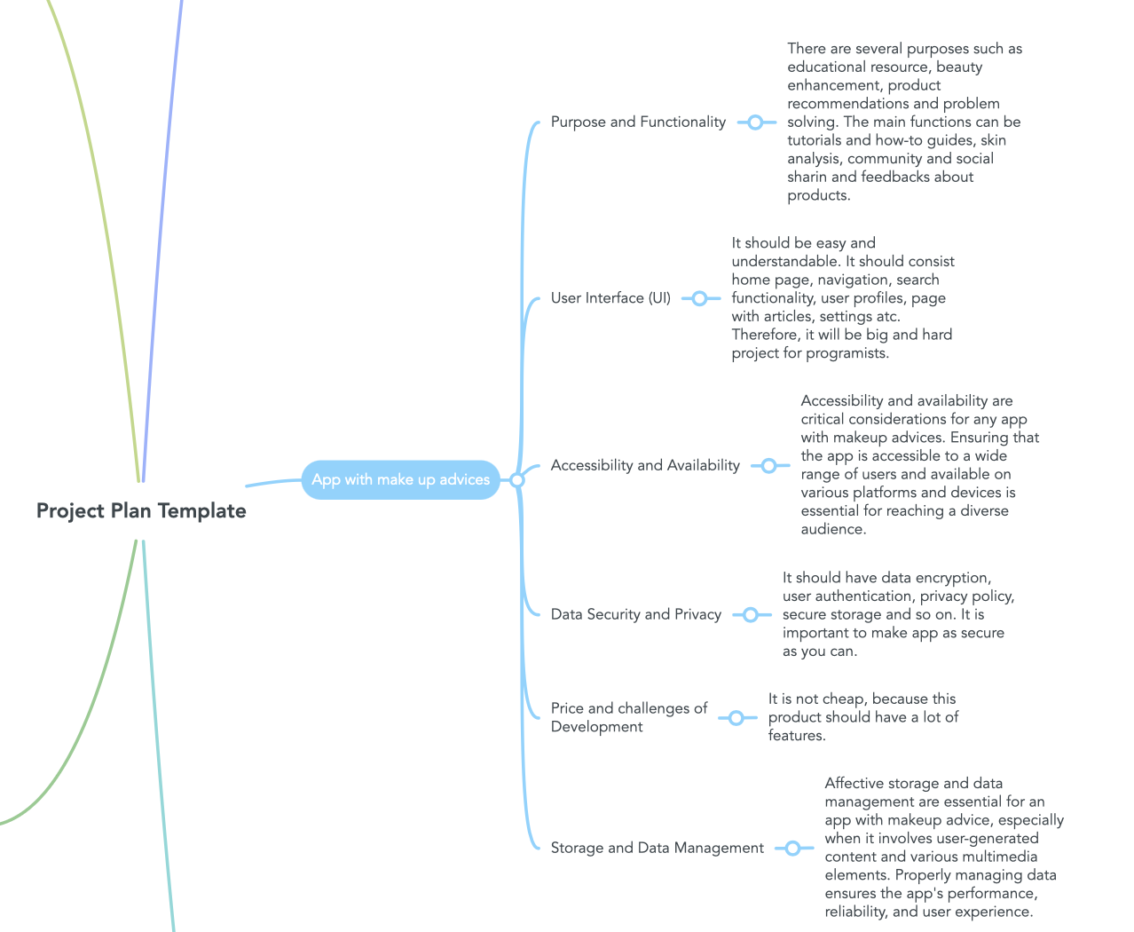

**Figure 4. Idea №4. App with make up advices**

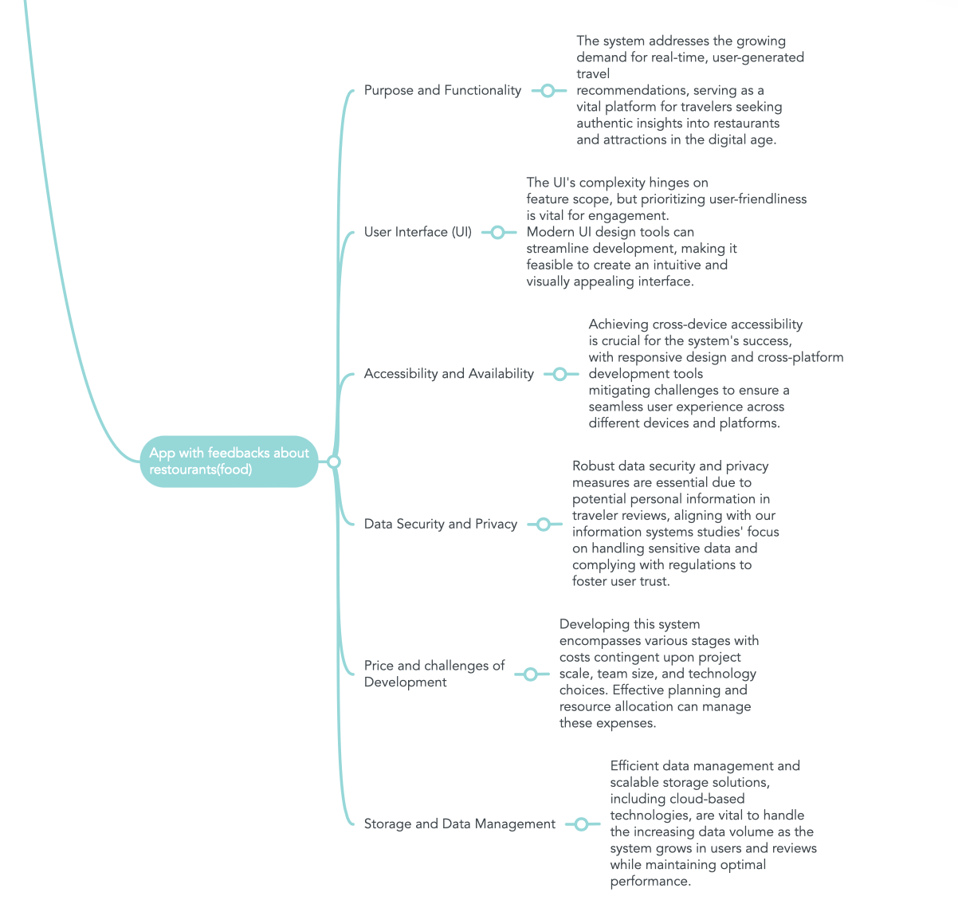

**Figure 5. App with feedback about restourant (food)**

Link to the map: <https://www.mindmeister.com/app/map/2937092351?t=qjmscG2fJj>

After comparing all the ideas, we settled on number 3 “VPN”.

# Analytic hierarchy process

As the person who was responsible for the AHP calculations faced problems with log in into this website the team decided to discuss all questions in a group at once and then on the basis of those answers the AHP will be made by one person.

As you can see the main priorities of criteria were GUI which represented how easy would be to create a GUI for specific project and Price of the developing the project.

As you can see VPN project were successful in Purpose and Functionality, GUI, Accessibility and Availability and in Price as well. That meant that the group decided that the VPN project would find the most purpose, would be the easiest and the cheapest to implement and on top of that would be the most available project for users to use and for the team to search information about.

Because of that the VPN theme was taken by the team.

Link: <https://bpmsg.com/ahp/ahp-hiergini.php?sc=3ABuwA>)

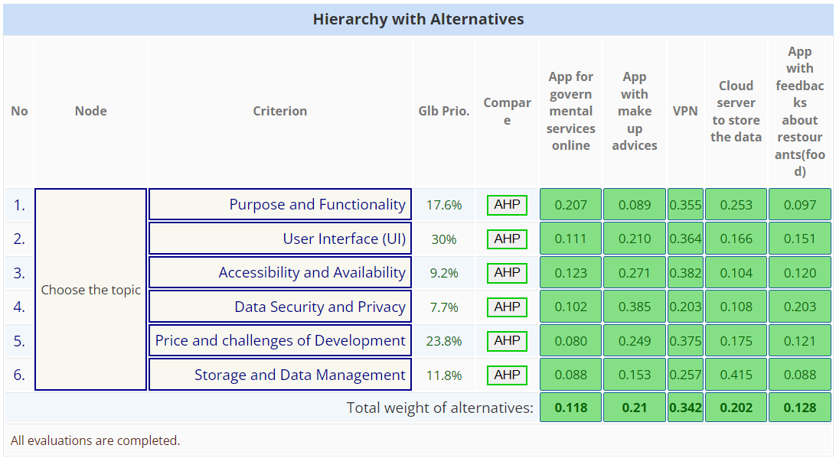

**Figure 6. AHP**

# Weekdone tool

All tasks according to the project we shared in Weekdone tool. This screenshot was taken before our trial version has ended, therefore not all tasks are fully complited on the photo. But we managed to understand how this application works, its functionality and the capabilities it provides to the user.

Here is a screenshot from this tool:

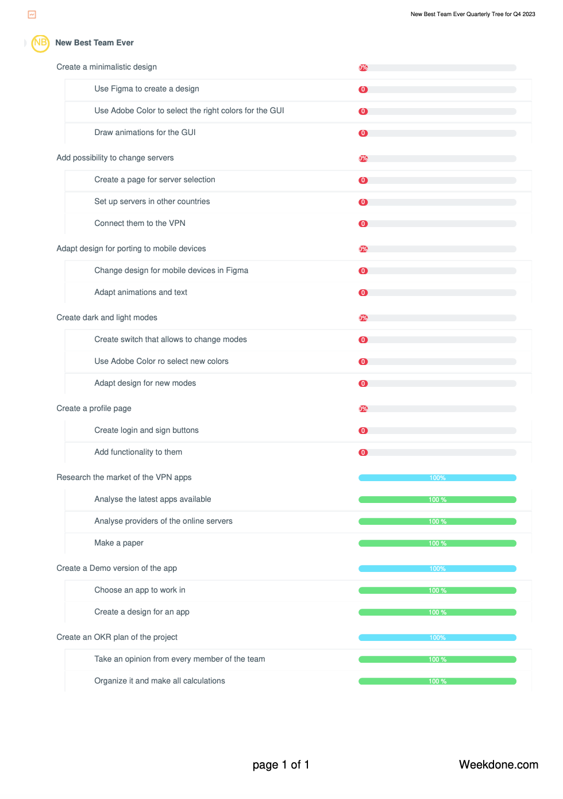

**Figure 7. Screenshot from Weekdone**

# OKR

Here is our OKR and explenation to it:

1) Create an OKR plan of the project (Oleksii Parshyn)

* 1. Take an opinion from every member of the team (This work was done in a group and unfortunately was not recorded, but on the basis of that work the calculations of AHP part of the project were done)
  2. Organize it and make all calculations (Basically AHP)

1. Create Risk Management Document
2. Create a Demo version of the app (Yehor Poliarskyi)
   1. Choose an app to work in (Yehor have chosen to work in Figma)
   2. Create a design for an app (Yehor created design for the demo)
3. Research the market of the VPN apps (Sofiia Chekmenova, Jaykumar Mathukiya, Stepan Kozlov)
   1. Analyze the latest apps available (Jaykumar Mathukiya, second part of the report)
   2. Analyze providers of the online servers (Sofiia Chekmenova, first part of the report)
   3. Make a paper (Stepan Kozlov, creation of the paper and SWOT analysis)
4. Create a minimalistic design (Discussed in Protocol 5)
   1. Use Figma to create a design (Yehor Poliarskyi with the help of Jaykumar Mathukiya)
   2. Use Adobe Color to select the right colors for the GUI (Stepan Kozlov)
   3. Draw animations for the GUI (Yehor Poliarskyi)
5. Add possibility to change servers (Discussed in Protocol 4)
   1. Create a page for server selection (First version was created by Oleksii Parshyn, main version was updated by Sofiia Chekmenova)
   2. Set up servers in other countries (Stepan and Oleksii analyzed the process and were stopped on the section were buying servers was needed)
   3. Connect them to the VPN (Stepan and Oleksii analyzed the process and were stopped on the section were buying servers was needed)
6. Adapt design for porting to mobile devices (Discussed in Protocol 1)
   1. Change design for mobile devices in Figma (Yehor Poliarskyi)
   2. Adapt animations and text (Yehor Poliarskyi)
7. Create dark and light modes (Discussed in Protocol 3)
   1. Create switch that allows to change modes (Yehor Poliarskyi)
   2. Use Adobe Color to select new colors (Stepan Kozlov)
   3. Adapt design for new modes (Yehor Poliarskyi)
8. Create a profile page (Discussed in Protocol 2)
   1. Create login and sign buttons (Jaykumar Mathukiya)
   2. Add functionality to them (Oleksii Parshyn: work in progress)

# Conclusion

To sum it up, our main goal was to explain our project using a Mindmap, share our AHP approach, display how we organized tasks using Weekdone, and outline our plan with OKR. We started by mapping out our project ideas in a Mindmap, helping us get a clear picture. AHP method then guided our decision-making process, making it more organized. Weekdone made task-sharing a breeze, showing who's doing what. It made teamwork smoother with a clear view of everyone's responsibilities. Lastly, our OKR plan is like a roadmap. It lists what we want to achieve and how we'll measure success. It's our guide to reach our project goals. Together, these tools and plans make our project management strong and effective.